**Recycling Market Development Advisory Council (RMDAC) Meeting**

**South Carolina Department of Commerce**

**3678 Centre Cir, Fort Mill, SC 29715**

**Thursday, March 15th, 2018**

**10:00 a.m. to 12:00 p.m.**

**RMDAC**

Wes Westbrooks, BMW

Carol James-Gilchrist, Sonoco Recycling

Tina Huskey, Mumford Industries

Norman Chandler, Republic Services

Angel Lara, Southeast Recycling Resources

Bill Laursen, Universal Environmental Services

Chuck LaGrange, Greater Greenville Sanitation Commission

Andy Spicer, Ph.D. USC Darla Moore School of Business

Chad Prescott, Mid-Carolina Steel

Esther Murphy, Horry County Solid Waste Authority

Vic Carpenter, Kershaw County

**ABSENT**

Kristen Brown, WasteZero

Brad Dutton, FiberQuest

Drew Smith, Michelin

**GUESTS**

Glenn Odom, Retired

Ronnie Grant, Retired

Ashely Teasdel, SC Commerce

Nikki Brown SC Commerce

Madison Burke, WEIMA

**STaff:**

Chantal Fryer, SC Department of Commerce

Anna DeLage, SC Department of Commerce

**Call Meeting to Order**

Wes Westbrooks motions to call the meeting to order 9:05am

Acknowledgement of visitors

**Minutes**

Minutes approved for the January 2018 meeting.

**Discussion**

Chantal Fryer provided an overview and highlights of the ongoing activities of the Recycling Market Development program by presenting the dashboard.

Annual Report: RMDAC’s 2017 Annual Report is due March 15 to Governor and General Assembly. The report is complete (except for final DHEC numbers).

Don’t Waste Food SC:

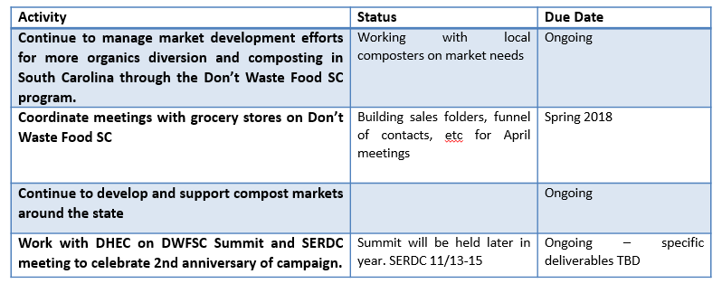

Carolinas Plastics Recycling Council and Carpet Recycling Coalition:

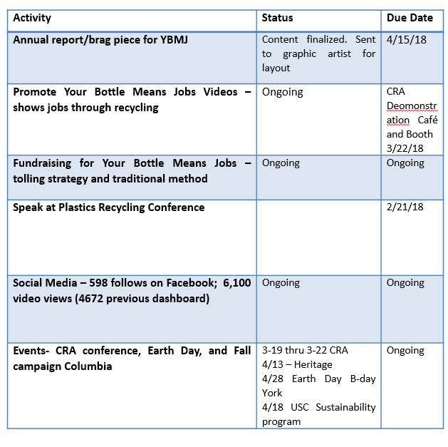

Other Activities:

|  |
| --- |
| **Develop robust marketing and outreach effort to communicate economic impact information such as with newsletters, social media, etc. (ongoing)** |
| **Conduct visits of recycling businesses (ongoing)**  **PTI Tool and Gasket**  **Palmetto Goodwill** |
| **Respond to recycling business assistance requests and site visits generated through referrals by the Existing Industry team at SC Commerce (ongoing)**  **Nine Lives Mattress Recycling** |
| **Manage RMDAC initiatives and provide oversight of meetings. (ongoing)** |
| **Provide oversight of glass recycling activities in the state to include Upstate and Midlands recycling activities.**  **March 15 GPI Board meeting to review G’ville County proposal**  **Horry County glass system can sort a stapler. It’s a must see. ROI for equipment is modest. $300,000 initial investment. This kept the market for glass recycling alive and well even in tough economic times.**  **If you had a glass operation system this could be an investment in Upstate. Who could invest in the processing could this be a partnership?**  **BMW has been working with Fisher Recycling to identify glass recycling strategies. Challenge is having a committed end market. RAM Recycling has been working with Fisher Recycling to provide business glass recycling services in the Upstate.** |

Wes Westbrooks recognizes Esther Murphy for her 4 years of service.

**Annual report:** The Recycling Market Development Advisory Committee presented the General Assembly with the Recycling Market Development Advisory Committee 2017 Annual Report.

As the recycling industry continues to grow, new companies are coming to South Carolina and existing industries are expanding their operations.  The report details commodity market valuation as well as the SC Department of Commerce Recycling Market Development work plan. You may view the report [here.](https://www.canva.com/design/DACxd1w6CNc/oowytTDgTOtPXs3dpBY-3g/view?utm_content=DACxd1w6CNc&utm_campaign=designshare&utm_medium=link&utm_source=sharebutton)

**Website Update:** To better serve the recycling sector, S.C. Department of Commerce's Recycling Market Development team restructured and relaunched its website -- [**www.recyclinginsc.com**](http://www.recyclinginsc.com). Featuring a customizable experience platform, the new site serves as a resource for industrial and residential users, alike.

In addition to housing a free [**recycling business directory**](https://www.sourcesc.com/companies/#recycling) complete with keyword search functionality, the site also includes easy-to-locate recycling videos, commodity maps and more. [**Toolkits for important initiatives**](http://r20.rs6.net/tn.jsp?t=97g7qv7ab.0.0.ubyi4cpab.0&id=preview&r=3&p=https%3A%2F%2Fwww.recyclinginsc.com%2Fabout-us%2Frecycling-resources%2F), such as Your Bottle Means Jobs and Don't Waste Food S.C. are also housed on the new site.

**Successes in SC:** Phase 2 of the website can include a success stories segment that highlights best practices in recycling similar to the [SC Commerce](https://www.sccommerce.com/why-south-carolina/success-stories) site.

**Industry Appreciation:** Will be held April 26th at 701 Whaley. Nominees will be sent to the executive committee for review.

**Discussion**

Opportunities

* Mandatory recycling, requiring industry to recycle can increase collection rates. Mixed paper collection will have a cost.
* Going back to separating materials.
* Developing recycling infrastructure.

Weaknesses:

* Need to require business reporting to collect accurate data.
* SCAGPO: State procurement has a 25% requirement for recycled content, are departments aware of this?
* Alternative Sources of Energy: Generate other ways to handle hard to recycle materials. Cons devalues material, once you open these facilities you have to feed the beast.
* Single stream has increased contamination and that has had a ripple effect in the market place.

Staff Request: RMDAC would like staff to invite a waste-to-energy company like Repower South or Covanta to the next meeting to discuss potential.

Discussion may be framed by considering **competitiveness** vs **dealing with disruptive change** in the marketplace.

**Competitiveness:** How do we become more competitive and keep up with our neighbors? (this could be a good sell in the legislature)

**Disruptive change** **in the market**: Technology, China is closing its doors on material exports are we prepared, staple fiber market doubling is disrupting carpet recovery, how do we best support the industry?

Legislators that have sponsored legislation in the past: Chandra Dillard and Senator Cleary

Staff request: RMDAC would like to receive any information regarding current recycling legislation

Market Updates:

(Esther) Glass: Same

(Angel) Metals): Prices are up, good for steel and aluminum industry, proposed legislation will affect the consumer.

(Carol) Paper: Paper is down, mixed paper is an issue, paper team looking on solutions. Looking at consuming more mixed paper options. Cardboard not looking much better when China pushed back on OCC. Some companies can’t move material market price of OCC is $95, contracts are moving spot times are not moving, Pratt has a mill that only consumes mixed paper. Feed stock pricing for mixed paper is cheap. American Cheng Nam received contract from West Coast the buying arm for largest paper mills in China. This could lead to an uptick of materials moving to China.

(Tina) Recycling: The GSA book of lists only included one recycler. This has gone down from past years. Clean, sorted material is moving. People are grinding their own material and using it in their product

(Norm) Solid Waste: Solid waste is doing well. Filter cakes and sludge’s are expensive to process because of how they contaminate the leachate. We are seeing a trend where these materials will be priced by how many gallons of liquid will be released. May need to slow down those trucks because these liquid waste can be problematic.

(Bill) Oil: Opened at $65 barrel trending the right way.

(Glenn) Carpet: Nylon 6 still does not have any value. PET has no value, looking at non wovens next. CARE investing $50,000 a year to conduct PET testing. PET is 50% of the carpet market. Wellman is using a lot of Nylon 66. Community programs, looking at cost sharing. Pitt County, Georgetown have signed on.

(Chad) Non-Ferrous: Aluminum is doing well. Scrap appointments are out 3 months, slow shipping, and upward pressure on market.

CRA conference will be held next week in Cherokee, NC.

Lunch Break

Madison Burke gives Weima overview.

**Weima** has focused 25 years on the science of shredding, grinding and briquetting, continuously improving technologies to bring customers the very best options for handling production waste management.

Keer is using briquetting equipment after SC DOC referral.

Trade shows serve to reconfirm to customers that Weima is a strong presence. There is a focus in selling beyond just the first machine. Weima will be the machinery sponsor of the NPE in Orlando, FL.

Weima won the Best of German Engineering award.

They have offices in China, Germany, and Fort Mill, SC. Plan to open a West Coast location.

In Germany they have a technical arm and heavy machinery manufacturing arm.

Weima can build a large machine a week.

Equipment: WEIMA has a whole range of briquette shapes and sizes available for metals, paper, wood, plastic, biomass, and waste. The machines can be configured to produce briquettes of a specified size and shape. All models boast robust construction and require minimal maintenance, and are able to be easily integrated into any production line. All applications are different, but the goal is the same: to ensure that your shredder adds value to your operation. A WEIMA shredder makes it easier to transport, clean, sort, and/or reuse materials.

Largest machines have been used in aerospace and biomass processing for elephant grass.

Who is using the machines? The Watchtower, Cryovac, SC Plasics, Southern Lumber (Charleston), Ashley Furniture to name a few examples. There is a lot of wood processing happening in NC.

Tour

Video: Ocean plastics [video](https://www.theguardian.com/world/video/2018/mar/06/so-much-plastic-british-diver-films-deluge-of-waste-off-bali-video) provided by Angel.

Adjourn 1:54pm